Policy for the Reception Period

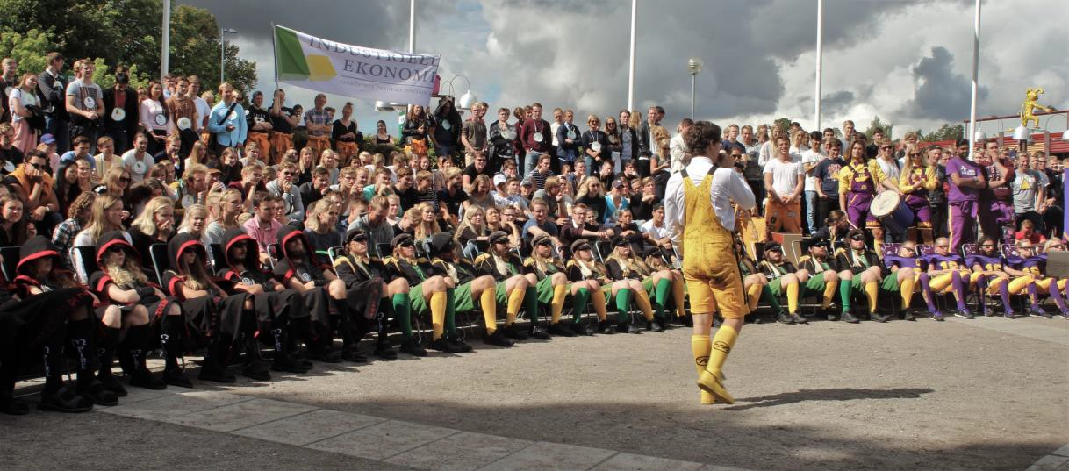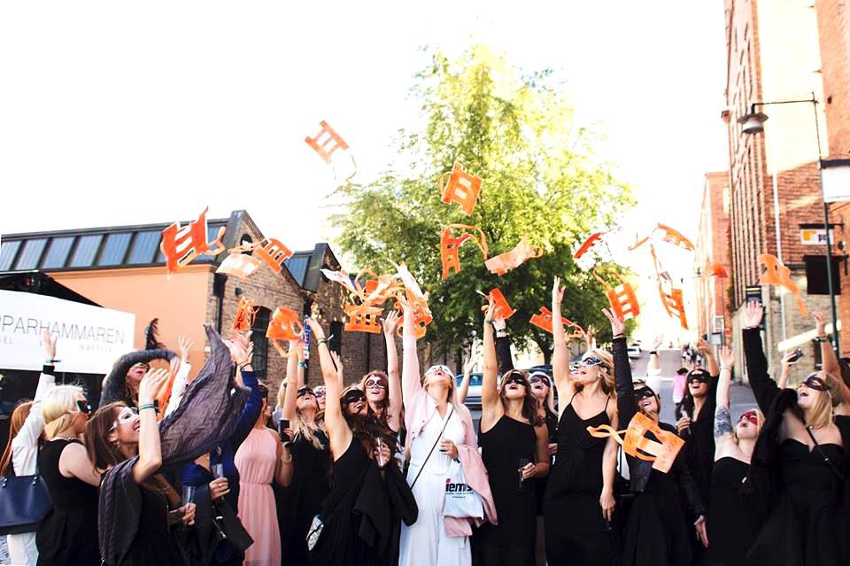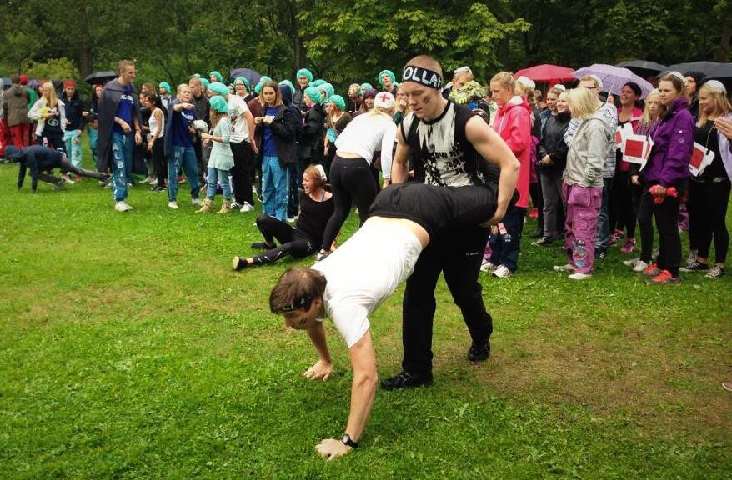
Approved
Photo: Consensus: Unknown, StuFF: Ofelia Ollila, LinTek: Camilla Blomberg

Preface
Consensus, LinTek and StuFF, known below as the “student unions”, together form “Linköping University Student Unions” (abbreviated “LUST”). LUST is an agency created to facilitate collaboration between the three student unions, and its purpose is to promote questions that concern all students at Linköping University, independently of the particular student union they belong to.

The student unions have been tasked by Linköping University to ensure that newly admitted students experience a positive reception at the university. In order to ensure that the reception activities maintain a high quality and are subject to development, the student unions have decided to draw up a common policy (under the auspices of LUST) describing how reception activities are to be conducted.
This policy document is principally intended to guide those who work with reception activities associated with the student unions, but will be of interest also for anyone who wants to gain insight into the reception activities at Linköping University.
The policy is to be evaluated after each year of reception activities, in consultation with all organisers and other stake-holders. It is to be revised if necessary.

Gustav Hanstorp
Student support and welfare officer, Consensus

Irma Wenhov
Student support and welfare officer, LinTek

Andreas Lind
Student support and welfare officer, StuFF

Contents

Preface 2
Contents 3
1. Reception activities 4
1.1 The reception period 4
1.2 Purpose and goal of reception activities 4
1.3 Purpose of the policy for the reception period 5
2. Actors 6
2.1 Student unions 6
2.2 Organisers of reception activities 7
2.3 Mentors 8
2.4 Play actors 9
3. Regulations and standards during the reception period 11
3.1 Equal opportunities 11
3.2 Alcohol and other drugs 11
4. Activities 13
4.1 Missions 13
4.2 Competitions 13
4.3 Parties 13
4.4 Jester performance, Spectacle 14

Reception activities
Linköping University is renowned for the social introduction given to new students through well-organised reception activities.
The reception activities¹ take place at the start of each term. They are arranged by the students themselves through student associations that correspond more or less to educational programmes and/or courses at Linköping University.
The reception activities are highly appreciated by the participants, and the students who arrange them put in a lot of effort to make sure that new students have as good a start to their studies as possible. The time and effort put into the reception activities are also greatly valued and supported by Linköping University.
The social introduction that occurs during this period is very important for new students and creates norms for the studies to come. It is hoped that the new students feel at home, and that a good foundation for social interaction is laid that will endure throughout their time at Linköping University.
Due to the heterogeneity of the student population, activities during this period should be of a wide variety – it is important that all new students feel safe and welcome at Linköping University and life as a student.

The reception period
The “reception period” refers to the period during which an organiser arranges reception activities approved by the student unions. Two such reception periods are held each academic year, one in the autumn and one in the spring. Each reception period extends from the time at which the first organiser starts its reception activities until the last organiser concludes its reception activities, regardless of the organiser’s student union.
During the reception period, actors shall abide by the policy for the reception period when in contact with new students, for the entirety of the actor’s own reception period and until all other actors’ reception periods have concluded.

Purpose and goal of reception activities
The purpose of the reception activities is to welcome and prepare the new students for their time at Linköping University. Starting studies should be both fun and exciting, and the reception period is intended to be a period to remember for the rest of the student’s life.

1 The reception period is commonly known as “Nolle-P”. This name originates from the first study period of the Technical Faculty. The time before the first study period is “Period zero”, more commonly known as “Nolle-P” (which is approximately “Period zero” in Swedish). The name has been adopted across the entire university.

The goals of the reception activities are to give each newly admitted student the opportunity to build a social network and to lay the basis for effective study techniques.
The goals of the student unions for the reception activities are:

    - To make all newly admitted students feel welcome at Linköping University and welcome to participate in the reception activities
    - To provide activities that are characterised by variation and accessibility. Furthermore, to provide activities that are targeted to all new students, as far as possible.
    - To encourage new students to take their studies at university seriously
    - To ensure that no-one feels offended, harassed or discriminated
    - To ensure that all actors have a healthy attitude to alcohol during the reception activities
    - To enhance cooperation and integration between students taking different study programmes and attending different faculties.

Purpose of the policy for the reception period
The purpose of the policy is to ensure that the student unions and the other actors within reception activities take a united standpoint on what characterises a good reception for new students. It is hoped that the policy will induce a positive change in attitudes and norms, as it is in everyone’s interest that the reception of new students be carried out in as positive a manner as possible.

Actors
Several actors are involved at various levels in the reception activities at Linköping University. This policy applies to actors that are in any way linked to the student unions. All actors participate in reception activities on a voluntary basis – no one should be forced to participate. However, all actors who decide to participate in the reception activities must fulfil the undertakings they have accepted.

All actors are to demonstrate the serious nature of university studies during the reception activities.
Actors:
    - Student unions
    - Organisers of reception activities
    - Mentors – “Faddrar”
    - Play actors.

Student unions
The student unions work actively to ensure that all new students experience a positive reception and introduction to life as a student. Student unions encourage activities between sections and between faculties to promote community at Linköping University. In order to promote this, the student unions shall work to ensure that the various organisers of the reception activities cooperate.
The student unions cooperate with Student Health in training the organisers of the reception activities and mentors. This training includes issues around alcohol and drugs, as well as consideration of equal opportunities.
    - The student unions undertake to:
      - Make sure that every student union has one point of contact within their organisation with the purpose of improving communication between the student unions and other actors
      - Plan and execute training for the reception activities for organisers and mentors
      - Define the dates of the start and end of the relevant reception period
      - Make sure that representatives from the different organisers meet and coordinate their activities
      - Take responsibility that the policy for the reception period is evaluated

      - Provide information to all organisers of reception activities of any change of colour of the clothing of sobriety mentors at least four months before the start of the reception activities.

Organisers of reception activities
Organisers of reception activities include mentor committees (fadderier), master committees (mästerier), mentor groups (faddergrupper), and sections (sektioner). Organisers normally plan and implement activities during the reception period for newly admitted students at the section represented by the particular organiser.
Organisers may implement additional regulations for their reception activities in addition to the policy described here, as long as these do not contradict the policy described here. Such additional regulations must be approved by the relevant student union.
Several organisers implement a spectacle that lasts the complete duration of the reception period. More information about this is given below in the relevant section.
    - Organisers of reception activities undertake to:
      - Plan and be responsible for social activities during the reception period
      - Make sure that there is at least one person with principal responsibility for the reception activities during the complete reception period
      - Take responsibility that a contract with their student union regarding the reception activities is drawn up and signed
      - Participate in the training designed for organisers and provided by the student unions in collaboration with Student Health
      - Avoid conducting activities that can be perceived as offensive, harassing or discriminating
      - Act as role models for mentors and for new students
      - Make sure that the hand-over to subsequent organisers of reception activities is satisfactory for the new organisers
      - Ensure that all new students are informed when all participants in the spectacle have been identified
      - Take action if a newly admitted student is suspected of participating in the spectacle
      - Ensure that activities carried out in a public location create a positive impression of student life for the general public
      - Submit a description of their clothing (where relevant) to the student union for approval. This is to take place before a date set by the student union.
      - Present a plan of activities, budget, etc., to the responsible person at the the student union. This is to take place before a date set by the student union.
      - Ensure that mentors are provided with suitable clothing. Mentor clothing, where relevant, must not have the same colour as that of sobriety mentors, in order to make the difference between mentors and sobriety mentors clear.
      - Follow the same demands and undertakings as other mentors.
      - Take responsibility that external actors conduct themselves in accordance with the policy for the reception period.

Mentors
Mentors are existing students who volunteer during the reception period to welcome the new students. Mentors support the new students and help them find their place both socially and academically. This support is offered to all newly admitted students who need it, regardless of faculty or programme. In order to achieve this, the student unions and Student Health arrange training for mentors. This training is mandatory for all who are to act as mentors during the reception period. Both mentors and other actors should keep in mind that Student Health, Central Study Guidance and the student unions are available to provide support and resources.
    - Mentors undertake to:
      - Participate in all parts of the mentor training, or equivalent, and subsequently sign a contract with their student union. Mentors who participated in all parts of the training during the preceding year, however, only need to attend the second part of the training. Should any uncertainty about the whether a mentor should take the complete training again or not, the appropriate person at the student union shall be contacted.
      - Be aware of their role towards the new students, and not take advantage of their superior position.
      - As far as is possible, devote equal attention to all newly admitted students
      - Be aware of persons who risk exclusion from the group and of persons who misbehave
      - Be aware of their behaviour as representatives of the university. Give the new students the opportunity to form their own opinion about students taking other educational programmes at Linköping University, students at other educational institutions, employees at the university, and the various programmes and courses given here.
      - Be a guide to the studies and help the new students to acclimatise to the new type of academic environment they are facing as they start higher education
      - Prevent new students behaving in a way that is incompatible with the policy for the reception period, and take action if such behaviour occurs. (One example of such behaviou occurs if new students write a spectacle (gyckel)⁵ that is offensive, harassing, discriminating or unnecessarily explicit.)
      - Respect the work that the organisers have put into organising the reception activities
      - Respect all types of acting performance that take place during the reception activities
      - Participate actively for the complete reception period (exceptions may be made, in agreement with the organisers and the student union)
      - When participating in activities, remain in such a condition as to be able to take care of new students if required, with no regard of the educational programme or faculty to which the student belongs
      - Make it clear by clothing and/or accessories that they are mentors.

5 Spectacles are humorous performances or events that may include such elements as song, film and dance.

Play actors
The purpose of arranging spectacles is to provide the newly admitted students with material to experience in common and discuss. This is achieved by arranging unexpected events. Such a process counteracts the risk of individuals being excluded.
    - Guidelines for spectacles
      - Play actors are to design and execute the spectacle such that it is suitable for the intended audience.
      - At the end of the reception period, or earlier, the play actors are to discard the role they are playing in a clear manner.
      - Each play actor should try to minimise the risk of misunderstanding by behaving in a natural manner when dealing with non-students such as university personnel, shop assistants, etc.
    - Organisers
Several organisers implement a spectacle that lasts the complete duration of the reception period. The equipment, presentation and activities of the organisers must be characterised by an aura of responsibility.
    - Undercover groups
Undercover groups are groups of mentors who create together a spectacle that continues during most or all of the reception period. An undercover group may be the same as an organiser, but this is not necessary.
    - Role-playing mentors
Several mentors play various roles during the early phases of the reception period. They may pretend to be, for example, a newly admitted student or mentors who participate in various sketches. To avoid misunderstandings and rumours, the organisers, mentors and other affected parties are to know the identities of such mentors.
    - Play actors undertake to:
      - Follow the same demands and undertakings as other mentors. Exceptions from the requirement to use clearly identifiable clothing may be made in consultation with the student unions.
      - Describe their character, name and exposure to the person in charge of the reception period at the student union well in advance of the reception period, in order to have these examined and, where necessary, approved
      - In cases in which the play actor interacts with the newly admitted students: after the revelation present themselves in their true persona, such that the spectacle is given a clearly defined endpoint
      - Immediately drop out of character if anyone is offended by the character
      - Work to ensure that neither the new students nor people in the surroundings become afraid or uncomfortable as a result of the spectacle.

Additional undertakings for play actors who take the role of newly admitted student:
      - End their act during the third day of reception activities of the relevant organiser, at the latest. The first day as play actor should be at the roll call of newly admitted students (exceptions can be made in special circumstances).
      - Act with such an extreme character that no one will feel that they are in focus. This character may not be based on features that can be perceived as offensive, harassing or discriminating.
      - Avoid becoming too well acquainted with the new students when playing the role in the spectacle.

Regulations and standards during the reception period
A number of regulations and standards have been defined that all actors are to follow, in order to ensure the quality of the reception activities and make this period as welcoming and inclusive as possible.

Equal opportunities
Linköping University carries out active measures to ensure equal opportunities⁸. The goal is to ensure such diversity in the activities that as many as possible will be able to and desirous of participating during the reception period, and to ensure that the activities do not exclude anyone. No one during the reception period is to feel discriminated against for any of the seven grounds for discrimination:
    - Sex
    - Transgender identity or expression
    - Ethnicity
    - Religion or other belief
    - Disability
    - Sexual orientation
    - Age.
No one should feel offended or harassed. The interpretation given by person who experiences that he or she has been exposed to discrimination or harassment is to be given priority.
No forms of pennalism⁹ are to be carried out during the reception period.

Alcohol and other drugs
During the reception period, many values of student life are established and actors work to prevent newly admitted students developing harmful alcohol consumption habits. All actors must during the reception period follow the regulations for alcohol¹⁰ management given below. Illegal drugs are not allowed under any circumstances.
It is important to remember that some students are under 18 years old. Special regulations apply to such students concerning alcohol and entrance to student pubs and some events. Questions about the admission to activities during the reception period are to be sent to the person at the student union who is responsible for reception activities.

8 “Equal opportunities” is a collective term at Linköping University that includes all work with equality and gender, ethnicity and religious diversity, accessibility for persons with disabilities, sexual equality, transgender identity or expression, and age. It includes also all work against victimisation.
9 “Penalism” describes any form of peer oppression and bullying, and includes abuse, discrimination, harassment, etc.
10 See Chapter 1, Section 5 of the Alcohol Act (2010:1622). “The term ‘alcoholic beverage’ is used to denote a beverage with an alcohol content that exceeds 2.25% by volume.”

    - The following principles apply to reception activities:
Organisers of reception activities
      - Organisers of reception activities must follow the regulations established by the municipality and Swedish law concerning the serving of alcoholic beverages.
      - The first evening of the reception period is to be alcohol-free, in order to demonstrate that the principal focus of the reception activities is not to drink alcohol.
      - At least half of the days during the reception period should be alcohol-free. Such days should be evenly spread throughout the period, and the maximum consecutive period during which alcohol may be served is two days.
Mentors
      - Alcoholic beverages should not be a necessary element of activities – it should always be acceptable to remain sober during activities.
      - Mentors should set a good example, and handle alcohol sensibly.
      - Actors may not consume beverages with a higher alcohol content than 5.0% by volume, with the exception of units for which the organiser has received special permission from the student union.
      - Intense encouragement for an unhealthy consumption of alcohol must not take place. In the event of the slightest uncertainty, contact the responsible person at the student union.
Sobriety mentors
      - Sobriety mentors must remain sober.
      - At every activity at which alcohol is available, there must be at least one sobriety mentor for each 20 new students. There must be at least two sobriety mentors present at each activity.
      - Sobriety mentors shall wear special clothes or other identifying armbands provided by the student unions in order to make their identity clear.
      - At every activity at which alcohol is available, sobriety mentors must be present from the start of the arrangement until its end.
Outlets
      - Water must always be available free of charge at activities at which alcohol is served.
      - It must always be easy to choose a non-alcoholic beverage, and the non-alcoholic beverages should be presented in a visible and positive way.
      - At least one of the non-alcoholic beverages (in addition to water) should be cheaper than beverages that contain alcohol.
      - Intrusive marketing that encourages the consumption of alcoholic beverages is not permitted.
      - At activities at which alcoholic beverages are available and where the organiser is responsible for the sale of such beverages, no beverages stronger than 5.0% alcohol by volume may be served or sold without special permission from the student union.

Activities
The purpose of the activities during the reception period is to help new students get to know other students and their surroundings. The goal is for students to feel connected to everything, from fellow students to the university in its entirety.
The following principles apply to activities:
      - No social activity may interfere with scheduled studies. The schedule for new students is to be taken into consideration when planning activities.
      - Activities on an evening before a weekday must end by 1.00 am.
      - Activities during the reception period must be arranged in such a manner that they appeal, as far as possible, to all new students.
      - The organiser/organisers are responsible for all content of the activities.

Common activities during the reception period are listed below.

Missions
A mission is a voluntary task normally intended to be solved by a group. Such missions must not be too burdensome for an individual student, and it should be possible to complete them during the reception period. All missions must be free of charge for the newly admitted students.
A mission may not be used as a way to get tedious work done for the organisers of the reception activities, or for anyone else. The missions must not be degrading or offensive.

Competitions
Competitions aim to create affinity in a larger group, where many are engaged to achieve a common goal. It is important that these efforts result in raising the group in a way that is not at the expense of any other group or individual.
If bribery takes place, the bribes should be free of charge for the newly admitted students. Alcohol must not be used as a bribe in any circumstances. Creativity and ingenuity should be encouraged.

Parties
The main purpose of the parties and other evening activities is to give the new students additional opportunities to get to know each other, but they also aim to explore the multifaceted student life.

It is of utmost importance that organisers know the rules that apply at the location of any party that is arranged. It is particularly important to apply for permission to hold events in public places where this is necessary, and for permission to serve alcohol at private parties.
Read more in the section Alcohol and other drugs.

Jester performance, Spectacle
Jesting, or a spectacle (“gyckel” in Swedish) is a major part of the entertainment during the reception period and is an important student tradition. For many new students, the reception period is the first time they encounter the phenomenon of jesting. For this reason, it is important to choose a jesting performance with great care, and to avoid performances that can be interpreted as offensive or insulting.
An example of the type of jest to be avoided is the mocking of other sections, faculties, universities and similar. Other examples to avoid are jests with racist or coarse sexual allusions, and all forms of striptease. It is extremely important that the jest does not denigrate any other group or person. Nothing that encourages unhealthy consumption of alcohol may be included in the performance.
For more information see the section above entitled Equal opportunities.
All jesting performances that are to be performed during the reception period must be submitted for review and approval by the student union that represents the group for which the performance is to be held. Approval of jesting performances will always use the policy for the reception period as a basis for reaching a decision.
More instructions about jesting during the reception period are available in Gyckelguiden.

